ish¿u ysñlï weúßKs $ All Rights Reserved

St. Peter's College

St. Peter's College

St. Peter's College

புனித பேதுரு கல்லூரி

புனித பேதுரு கல்லூரி

புனித பேதுரு கல்லூரி

புனித பேதுரு கல்லூரி

புனித பேதுரு கல்லூரி

புனித பேதுரு கல்லூரி

புனித பேதுரு கல்லூரி

புனித பேதுரு கல்லூரி

Ydka; mS;r úÿy,

Ydka; mS;r úÿy,

Ydka; mS;r úÿy,

Ydka; mS;r úÿy,

Ydka; mS;r úÿy,

Ydka; mS;r úÿy,

Ydka; mS;r úÿy,

Ydka; mS;r úÿy,

Ydka; mS;r úÿy,

Ydka; mS;r úÿy,

St. Peter's College

St. Peter's College

St. Peter's College

St. Peter's College

St. Peter's College

St. Peter's College

St. Peter's College

St. Peter's College

St. Peter's College

St. Peter's College

புனித பேதுரு கல்லூரி

புனித பேதுரு கல்லூரி

புனித பேதுரு கல்லூரி

புனித பேதுரு கல்லூரி

புனித பேதுரு கல்லூரி

புனித பேதுரு கல்லூரி

புனித பேதுரு கல்லூரி

புனித பேதுரு கல்லூரி

Ydka; mS;r úÿy,

Ydka; mS;r úÿy,

Ydka; mS;r úÿy,

Ydka; mS;r úÿy,

Ydka; mS;r úÿy,

Ydka; mS;r úÿy,

Ydka; mS;r úÿy,

Ydka; mS;r úÿy,

Ydka; mS;r úÿy,

Ydka; mS;r úÿy,

St. Peter's College

St. Peter's College

St. Peter's College

St. Peter's College

St. Peter's College

St. Peter's College

St. Peter's College

31

E

I, II

**bx.%Sis**

**English Language**

**meh 02**

**Two Hours**

**06 fY%aKsh – m<uq jdr we.hsu - 2023**

***Grade 06 – First Term Examination - 2023***

Ydka; mS;r úÿy, - fld<U 04

புனித பேதுரு கல்லூரி, கொழும்பு 4

***St. Peter's College - Colombo 04***



01. Form a word with correct spellings. The first one is done for you. **(5 Marks)**

a.F r ____ ____ n d b. O c ____ ____ n

c. A t h l ____ t ____ c d. ____ n j ____ y

e. L ____ b r ____ r y

02. Complete the table with the correct sounds **(5 Marks)**

**Ring Lip Cat Cot Play Cough Out Right Ear Seen Rain**

|  |  |  |  |  |  |  |  |
| --- | --- | --- | --- | --- | --- | --- | --- |
| Lot | *Cot* |  | Day |  |  | Rough |  |
| Gear |  |  | Sip |  |  | Mat |  |
| Been |  |  | Drain |  |  | Bright |  |
| about |  |  | Sing |  |  |  |  |

03. Complete the dialogue using the given phrases **(5 Marks)**

Sure, you can have it / In two days I’ll give it to you. / I am planning to read this book today. / It is Black Beauty / Good Morning Ramani. / It’s my pleasure.

Ramani : Good morning Kamal.

Kamal : (a) *Good morning Ramani.*

What are your plans for today?

Ramani : (b)______________________________________________________

Kamal : What is the name of that book?

Ramani : (c)______________________________________________________

Kamal : Can you lend this book for me to read?

Ramani : (d)______________________________________________________

Kamal : When can you give it to me?

Ramani : (e)______________________________________________________

Kamal : Thank you.

Ramani : (f)______________________________________________________

04. Fill in the blanks with the correct helping verb - Is / am / are **(5 Marks)**

a. I *am* a student of St. Peter’s College.

b. She ___________ very pretty.

c. They ___________ in the English medium class.

d. Kamal ___________ interested in guitar music.

e. We ___________ in the western band.

f. He ___________ a friend of Ruhiru.

05. Write the correct question word in the blanks using the below given words. **(5 Marks)**

**(Where, How much, What, Why, When, Who )**

1. *What* is in the box? An ornament.

2. ______________ is my glasses? In the case.

3. ______________ is the sports meet? On 25th of this month.

4. ______________ is your class teacher? Mrs. Samanthi

5. ______________ is this bag? Rs.2500.00

6. ______________ is she late? Due to the bus strike.

06. Form questions from the given sentences. **(5 Marks)**

a. She is studying. Is she studying?

b. They are listening to songs. _________________________________________

c. You are clever. _________________________________________

d. We are proud Peterites. _________________________________________

e. Ravin is playing the flute. _________________________________________

f. They are practicing basketball. _________________________________________

07. Fill in the blanks with the correct plural form of the noun in brackets. **(5 Marks)**

**The first one is done for you.**

**(Child, bus, bridge, subject, computer, teacher)**

1. Our class teacher teaches us several *subjects*.

2. All the ______________________ were crowded because of the rush hour.

3. We saw many ______________________ playing in the playground.

4. All the ______________________ are in the main hall at a meeting.

5. Lot of ______________________ got affected with the virus.

6. I walk over many ______________________ to reach the destination.

08. Re-write the given sentence with plurals. (5 Marks)

a. She cooked a potato. They cooked potatoes.

b. I took a photo for the Identity Card. _______________________________________

c. A monkey ate a mango. _______________________________________

d. A lady bought a hand bags. _______________________________________

e. He bought a loaf of bread. _______________________________________

f. He is a pilot _______________________________________

09. Read the below poem and answer the questions. **(10 Marks)**

Air moves from one place to another.

Moving air is called wind.

When air moves, we say a wind is blowing.

On some days, the wind blows gently.

This gentle wind is called a breeze.

A breeze makes us feel cool.

On some days, the wind blows fast and strong.

Sometimes, strong winds cause a storm.

Storms damage houses, harm the crop and uproot trees.

State whether below given sentences are True or False.

1. Storms are fast and strong winds.

2. Storms are good for crops.

3. Seeds are carried to different places by a wind.

4. Gentle wind is called breeze.

5. A breeze makes us feel warm.

Write the answers for the below questions

1. What is wind? ______________________________________

2. What is the reason for a storm? ______________________________________

3. Write three damages that the wind can do? ______________________________________

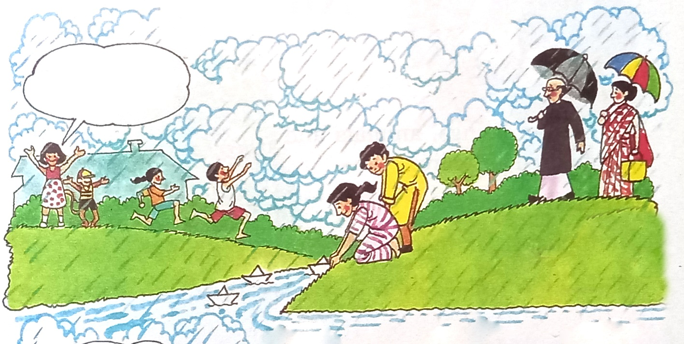10. Describe the below picture with five sentences. Each sentence should have more than 5 words. **(5Marks)**

_____________________________________________________________________________________________________________________________________________________________________________________________________________________________________________________________________________________________________________________________________________________________________________________________________________________________________________________________________________________________________________________________________________________________________________________________________________________________________________________________________________________________________________________________________________________________________________________________________________________________________________________________________________________________________________________________________________________________________________________________

11. Complete the paragraph using the words given in brackets. **(10 Marks)**

**(greater, saved, drugs, wounded, helpful, heal, lives, help, soldiers, healed, factories, scientists)**

Penicillin is one of the most useful (1) *drugs* man invented. With its (2)________________ we can (3)________________ wounds caused by bacteria which cannot be (4)________________ otherwise. It has (5)________________ power over bacteria. First (6)________________ and then ministers of governments showed interest in it. Since Penicillin could save(7)________________ soldiers, it could be (8)________________ during war. Authorities set up big (9)________________ for preparing it. It (10)________________ the lives of hundreds of thousands of (11)________________

12. Listening Test

Select the correct answer. **(8 Marks)**

1. Time of the day

Morning Afternoon Evening

2. All the students

Should be present

May be present

Must be present

3. On 30th June the College celebrates

College Day

Closing ceremony of Centenary year

College Day and the closing ceremony of Centenary year

4. Students need to be there

By 7.30a.m.

Before 7.30a.m.

By 9.30a.m.

Mark whether given sentences are true or false.

5. There will be a holy mass to start the ceremony.

6. All the parents are not invited Mini Carnival.

7. Mini carnival will not be held in the playground.

8. Rev. Fr. Rector has given the announcement.

13. Speaking Test **(12 Marks)**

14. Write an essay with one of the topics given below. Use 50-75 words **(15 Marks)**

a. My favourite animal

b. My best friend

c. My school

d. My village